Metropolitan
Transportation Plan
2045

for the Pine Bluff-White Hall Region
September
2020

2045 Metropolitan Transportation Plan
Southeast Arkansas Regional Planning Commission

This document is posted at:
www.searpc.com

For additional information, please contact:
Larry Reynolds, Director
Southeast Arkansas Metropolitan Planning Organization
1300 Ohio Street, Suite B
Pine Bluff, Arkansas 71601
Phone: 870-534-4247
Fax: 870-534-1555
Email: larryreynolds@cablelynx.com

Date adopted: September 29, 2020
Date amended:

This Plan was prepared as a cooperative effort of the U.S. Department of Transportation (USDOT), Federal Highway Administration (FHWA), Federal Transit Administration (FTA), Arkansas Department of Transportation (ArDOT), and local governments in partial fulfillment of requirements in Title 23 USC 134 and 135, amended by the FAST Act, Sections 1201 and 1202, December 4, 2015. The contents of this document do not necessarily reflect the official views or policies of the USDOT.

MPO Policy Committee
Name | Position
Ken Smith, Chairman | SEARPC
Scott Ray, Vice‐Chairman | Council Member, City of White Hall
Deric Wyatt | District Engineer, ArDOT
Inderpreet “Sunny” Farmahan | Planning Division, ArDOT
Shirley Washington | Mayor, City of Pine Bluff
Noel Foster | Mayor, City of White Hall
Gerald Robinson | County Judge, Jefferson County
Allison J.H. Thompson | Pres./CEO Economic Development Alliance for Jefferson County, AR.
Jimmy Lee Fisher Sr. | Quorum Court Member, Jefferson County
Joni Alexander | Council Member, City of Pine Bluff

Technical Advisory Committee
Name | Position
Rickey Bullard | Jefferson County Road Department
Ricky Rhoden | Street Manager, Pine Bluff Street Dept.
Cassandra Shaw | Manager, Pine Bluff Transit
Noel Foster | Mayor, City of White Hall
Brian Swinney | Construction Engineer, ArDOT
Anthony Hunter | Transportation Planner, ArDOT
Darrell Ray | Pine Bluff Police Dept.
Doug Hale | Manager, Pine Bluff Regional Airport
Rhonda Dishner | The Alliance
Valera McDaniel | USDOT, FHWA
Karen Quarles | Office of Emergency Management, Jefferson County Courthouse
Tony Barr | Transit Officer, Area Agency on Aging
Larry Reynolds* | Director, SEARPC*
*indicates non-voting status

This page is intentionally left blank.

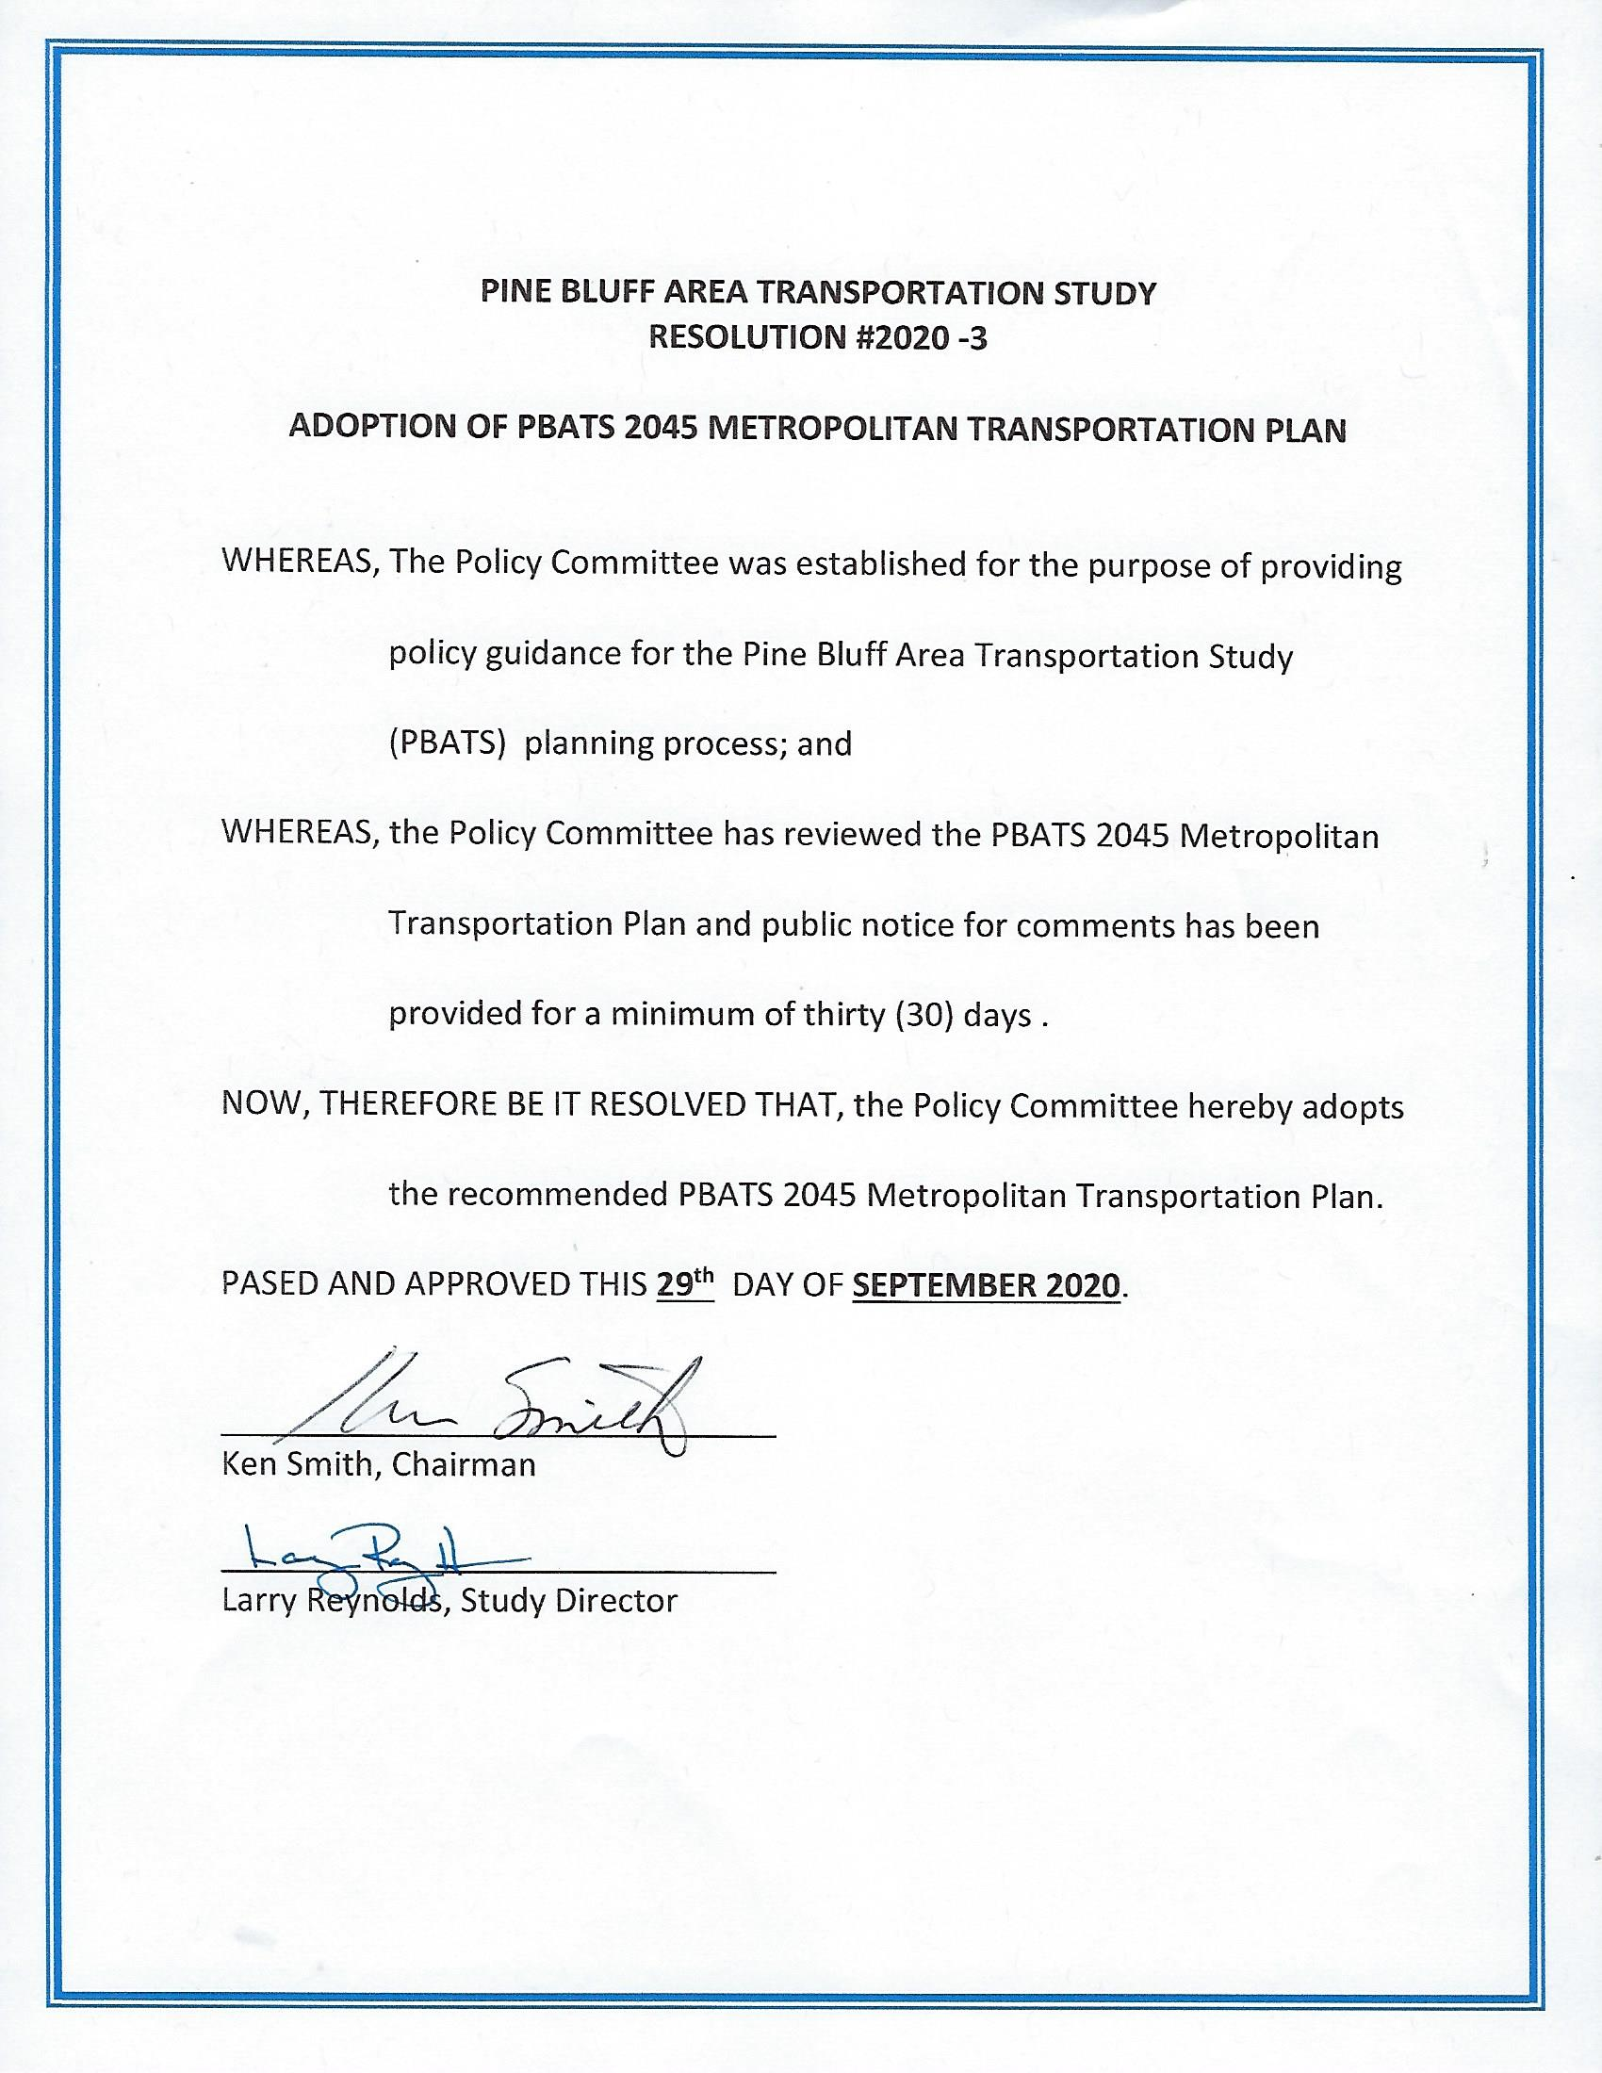
Table of Contents
1.0 Introduction 1
What is the Metropolitan Transportation Plan? 2
The Role of the Metropolitan Transportation Plan 2
What is the Metropolitan Planning Organization? 3
The Planning Process 4
Public and Stakeholder Involvement 4
2.0 Transportation Today 5
Roadway and Bridge Conditions 6
Bicycle and Pedestrian Conditions 7
Public Transit Conditions 7
Freight Conditions 9
3.0 Planning for Tomorrow 11
Growth Impacts 12
Changing Demographics and Travel Behavior 12
Connected and Autonomous Vehicles (CAV) 14
Electric and Alternative Fuel Vehicles 16
4.0 The Vision 17
Strategic Framework and Vision 18
Goals and Objectives 19
Performance Measures 20
5.0 Implementation 21
Strategies 22
Roadway Projects 24
Bicycle and Pedestrian Projects 34
Public Transit Projects 35
Next Steps 42

List of Tables
MPO Policy Committee ii
Technical Advisory Committee iii
Acronym Guide viii
Fiscally Constrained Roadway Projects 28
Visionary Roadway Capacity Projects 32
Public Transit Projects 40
List of Figures
Fiscally Constrained Roadway Capacity Projects 26
Visionary “Unfunded” Roadway Capacity Projects 30

Appendices
- Transportation Modeling and Forecasting
- Existing Conditions
- Transportation Performance Management Report
- Needs Assessment
- Plan Development
- Transportation Systems Management and Operations
- Federal Compliance Checklist

Acronym Guide
Acronym | Description
ADA | Americans with Disabilities Act
ArDOT | Arkansas Department of Transportation
BUILD | Better Utilizing Investments to Leverage Development (grant program)
CMAQ | Congestion Mitigation Air Quality program
EJ | Environmental Justice
FAST Act | Fixing America’s Surface Transportation Act
FHWA | Federal Highway Administration
FTA | Federal Transit Administration
GARVEE | Grant Anticipation Revenue Vehicle bonds
GIS | Geographic Information Systems
HSIP | Highway Safety Improvement Program
INFRA | Infrastructure for Rebuilding America (grant program)
ITS | Intelligent Transportation Systems
MTP | Metropolitan Transportation Plan
MPA | Metropolitan Planning Area
MPO | Metropolitan Planning Organization
PBT | Pine Bluff Transit
PPP | Public Participation Plan
SEARPC | Southeast Arkansas Regional Planning Commission
STIP | Statewide Transportation Improvement Program
STP | Surface Transportation Program
TAC | Technical Advisory Committee
TAP | Transportation Alternatives Program
TIP | Transportation Improvement Program
VMT | Vehicle Miles Traveled
TSM | Transportation Systems Management
UPWP | Unified Planning Work Program

1.0 Introduction
Learn about the background of the Metropolitan Transportation Plan and the regional organization that develops it, the Metropolitan Planning Organization.

What is the Metropolitan Transportation Plan?

A roadmap for addressing the region’s
transportation needs over the next 25 years
Updated Every 5 Years
All Modes of Transportation
Financially Constrained
Federal Requirement

The Role of the Metropolitan Transportation Plan

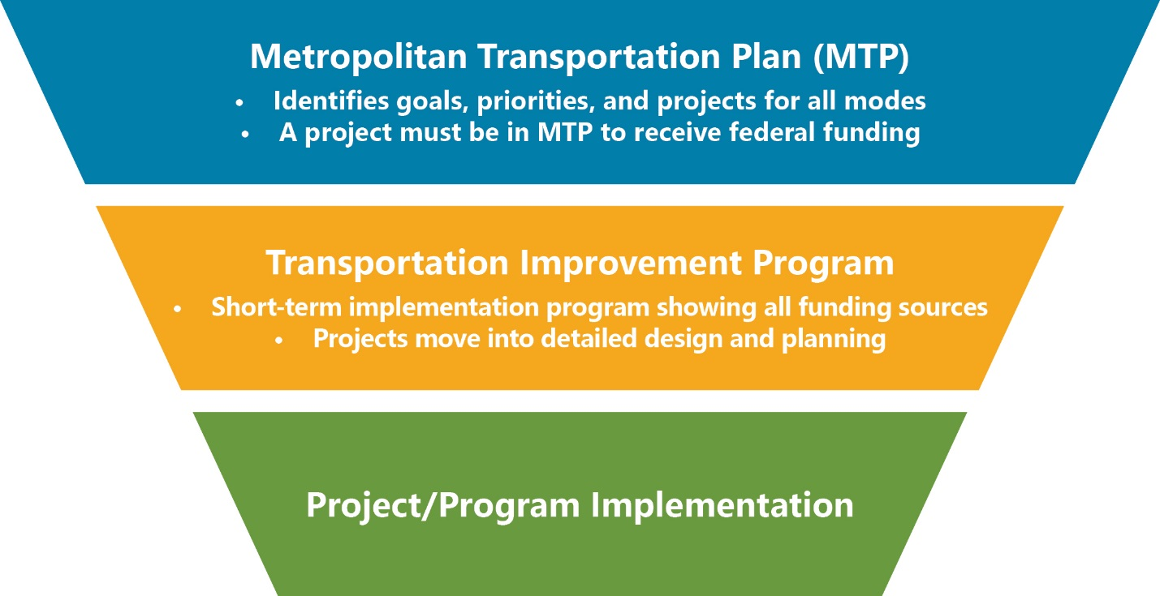

What is the Metropolitan Planning Organization?
All urban areas with a population of 50,000 or greater are required to have a Metropolitan Planning Organization (MPO) to conduct regional transportation planning.

The MPO Structure (How It All Works)
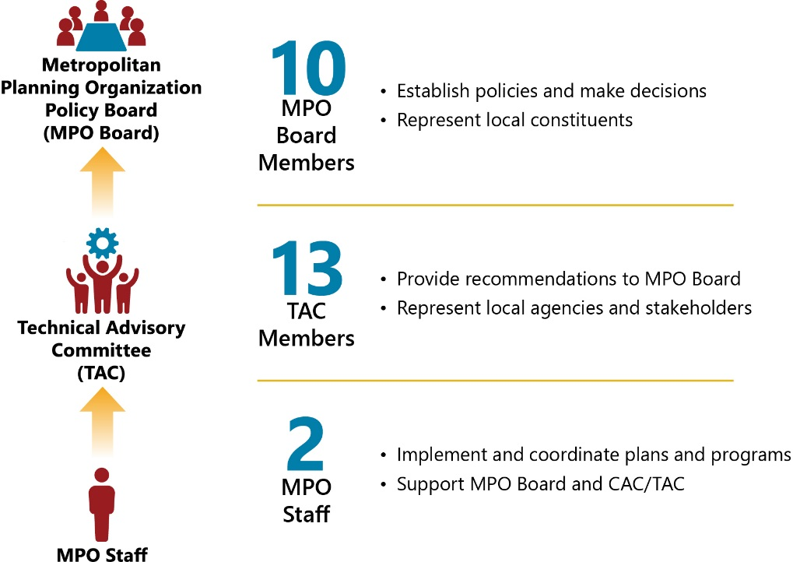

The Metropolitan Planning Area
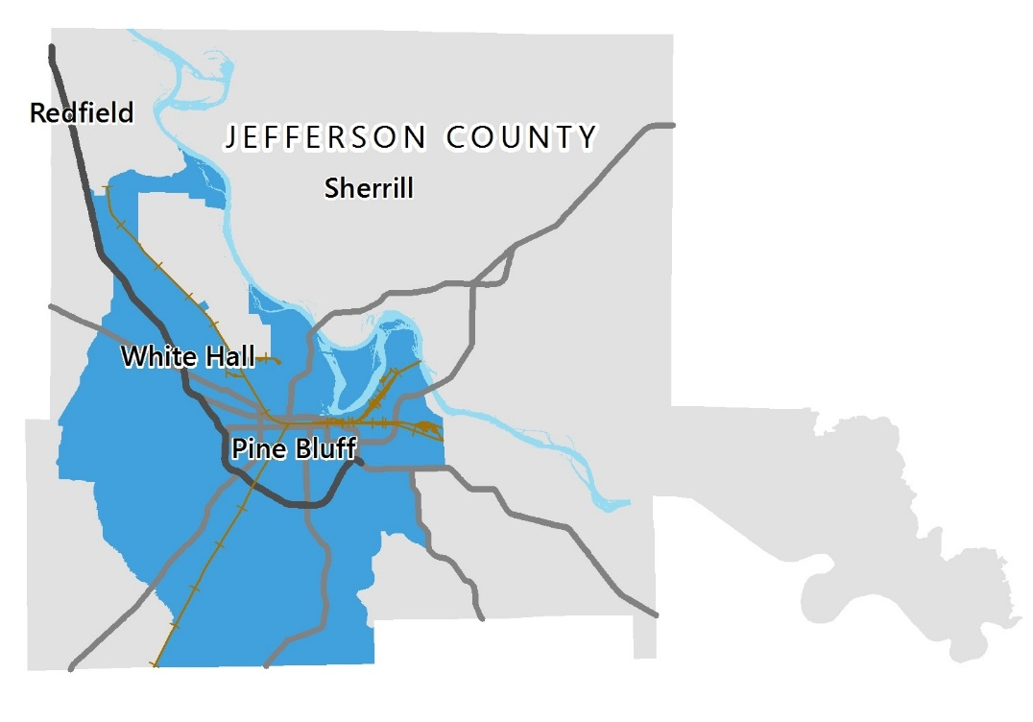
- Metropolitan Planning Area

The Planning Process

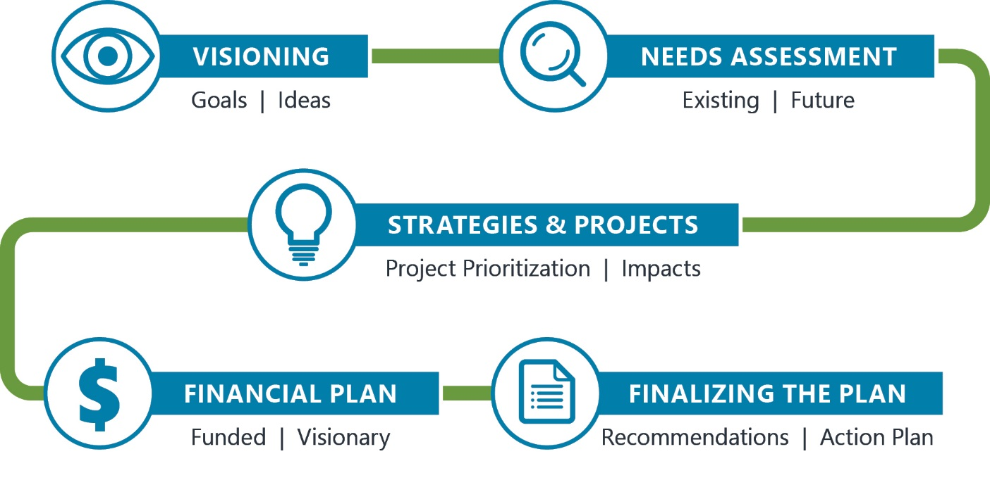

Public and Stakeholder Involvement
The planning process incorporated public and stakeholder input at key phases of the project, resulting in a plan that reflects local priorities and needs. The ongoing COVID-19 pandemic required the use of virtual public meetings and additional outreach.
+
+
=
35+
People Engaged

5+ People
from
Virtual Public Meetings
10+ People
from
Stakeholder Advisory Meetings

20 People
from
Online Public Surveys and Additional Outreach

Reference: Appendix #5: Plan Development, Chapter 2, Pages 2-4

2.0 Transportation Today
Review highlights of existing transportation conditions in the region for all modes.

Roadway and Bridge Conditions

Congestion – The region experiences very little congestion. Peak period delays occur at intersections on Sulphur Springs Road and S Blake Street.
Pavement Conditions – Most major roadways in the region have pavement in fair or good condition.
Bridge Conditions – The vast majority of bridges are in fair or good condition and bridges in poor condition have been identified.
Safety – From 2014 to 2018 there were 43 deaths and 181 severe injuries resulting from vehicular crashes.
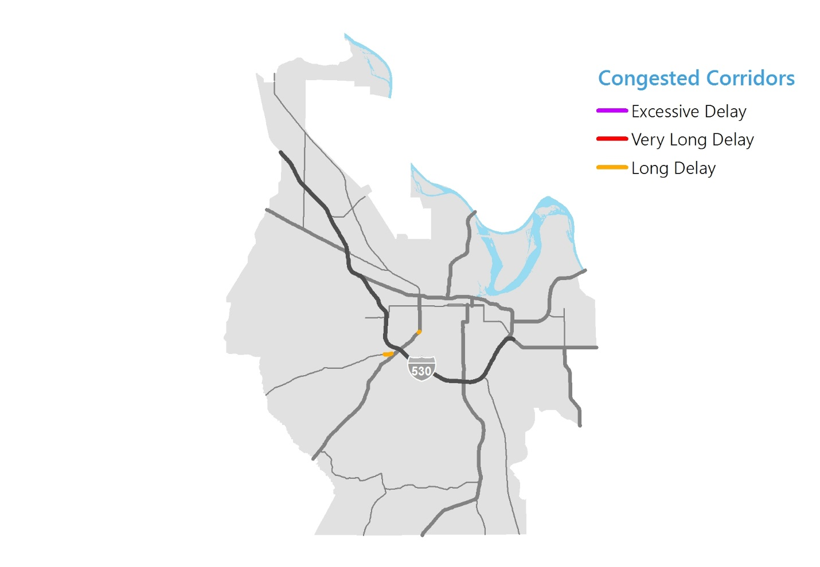
Reference: Appendix #2: Existing Conditions, Chapter 2, Pages 7-38

Bicycle and Pedestrian Conditions
High Demand Areas – The highest demand areas are around Downtown Pine Bluff, University of Arkansas at Pine Bluff, and the residential neighborhood southwest of N Bryant Street and Wormack Avenue.
Coverage – Bicycle and pedestrian infrastructure is limited outside of Downtown Pine Bluff.
State of Repair – The majority of the region’s sidewalks and bicycle lanes are in poor condition and need maintenance.
Safety – No bicycle crashes and 33 percent of pedestrian crashes from 2014 to 2018 resulted in an incapacitating injury or fatality.
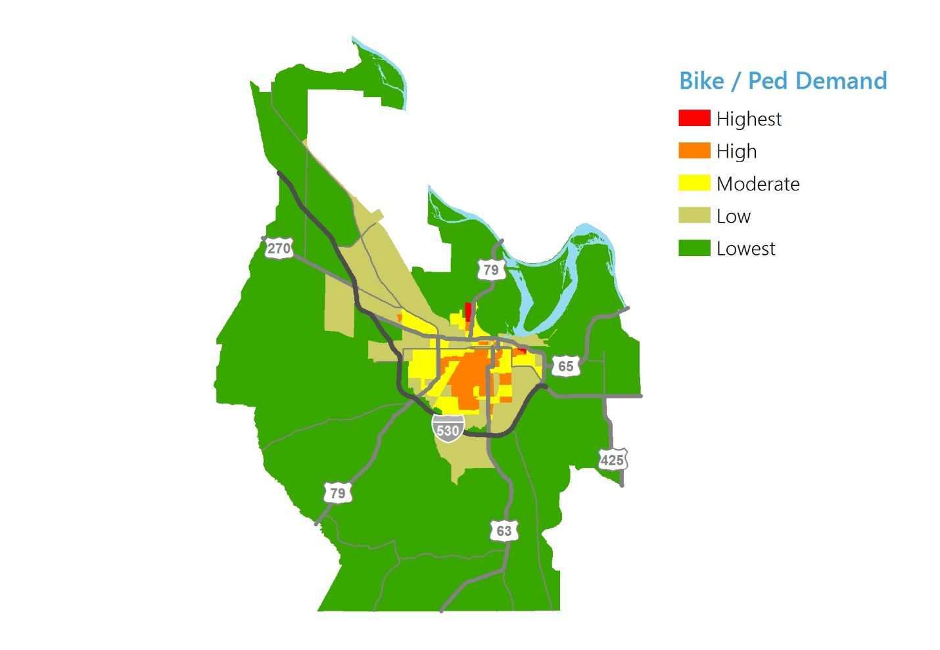
Reference: Appendix #2: Existing Conditions, Chapter 4, Pages 60-73

Public Transit Conditions

High Demand Areas – Most of the high demand areas are currently served by Pine Bluff Transit (PBT).
No Service to White Hall – There is currently no fixed-route service provided to the City of White Hall by PBT.
Maintenance – Most vehicles in the PBT fleet meet their useful life benchmark.
Safety – There have been few reported safety and security events in recent years for PBT and none involved fatalities or injuries.
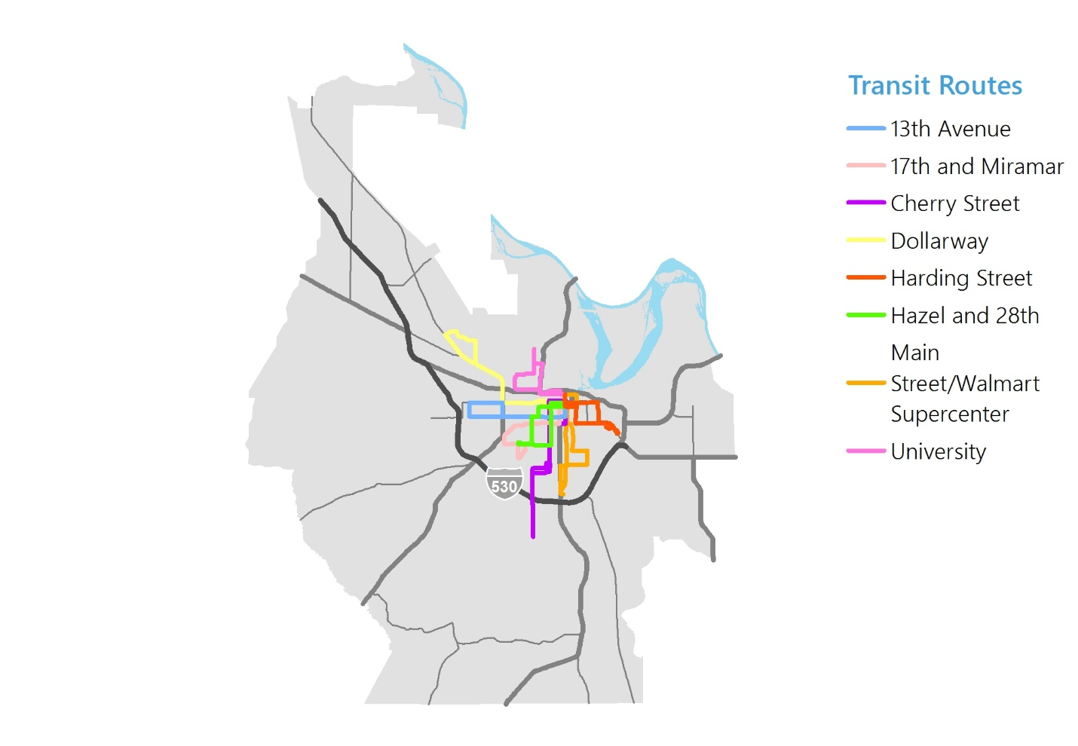
Reference: Appendix #2: Existing Conditions, Chapter 5, Pages 74-103

Freight Conditions

Highest Truck Traffic – The highest truck volumes are on Interstate 530, US Route 270, and US Route 65
Freight Truck Congestion – The biggest areas of concern for freight truck congestion is on Interstate 530 and S Blake Street
At-Grade Rail Crossings – There are over 44 at-grade rail crossings within the MPA.
Safety – Nearly five (5) percent of all fatal crashes in the region from 2014 to 2018 involved a heavy vehicle (e.g. freight truck).
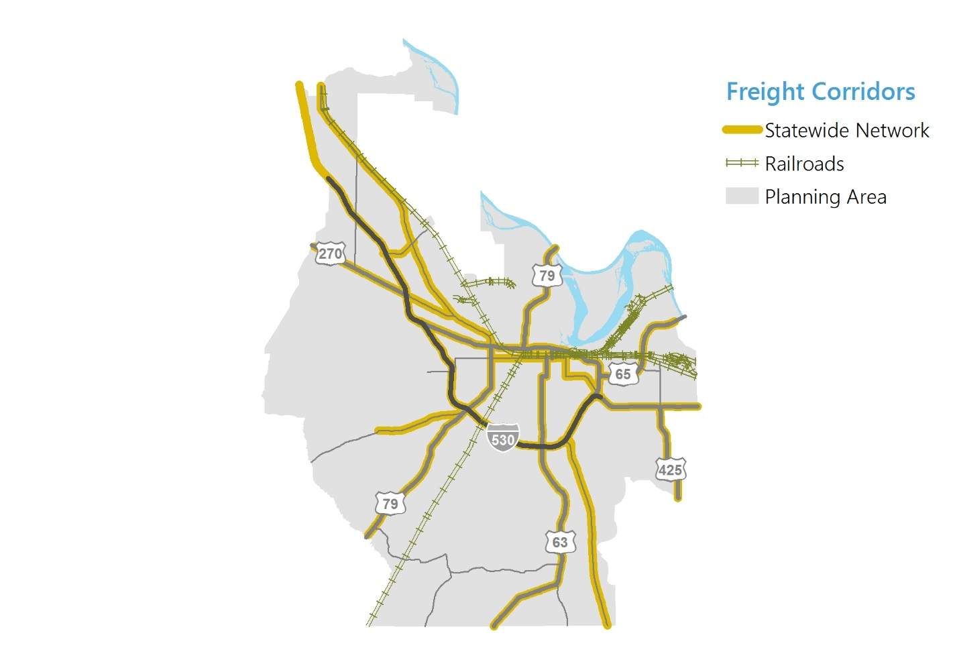
Reference: Appendix #2: Existing Conditions, Chapter 3, Pages 41-56

This page is intentionally left blank.

3.0 Planning for Tomorrow
Learn how growth and redevelopment, new mobility options, and evolving lifestyle preferences will transform the way people get around the region.

Growth Impacts
Over the next 25 years, the region will continue to grow at a slower rate than the state average. This growth will concentrate in a few particular areas, creating new transportation challenges and opportunities for the region.

Suburban Neighborhoods – Most residential growth is projected to occur at the edges of cities with very little occurring in existing areas.
Industrial Areas – Most industrial growth is anticipated to occur on the outer areas of the region.
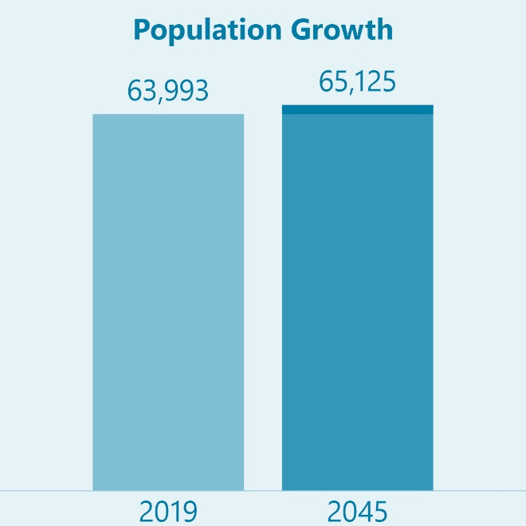
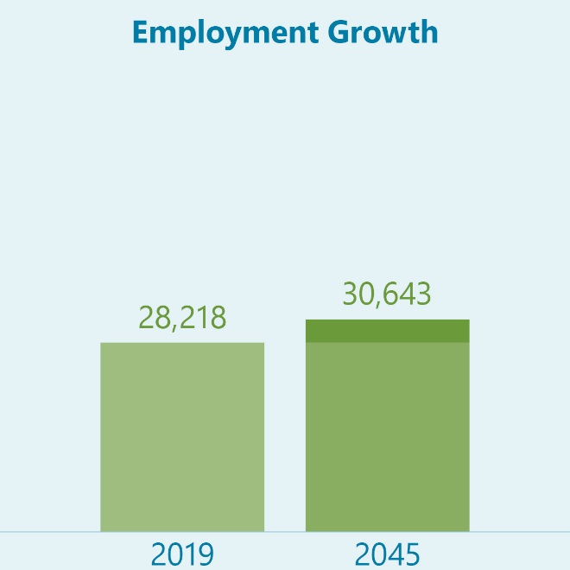
Commercial Areas – Commercial corridors are projected to expand in response to ongoing roadway projects, particularly US-270.

Note: These numbers are for the Metropolitan Planning Area – a portion of Jefferson County.
Reference: Appendix #1, Model Development, Chapter 9, Pages 40 and 41

Changing Demographics and Travel Behavior
In recent years, travel patterns have changed dramatically due to demographic changes and technological advances. Many of these changes are part of longer-term trends and others are newer, emerging trends.
The Population is Aging
The population aged 65 or older will grow rapidly over the next 25 years, nearly doubling from 2012 to 2050. This growth will increase the demand for alternatives to driving, especially for public transportation for people with limited mobility or disabilities.
Most People Are Traveling Less
Even before the effects of COVID-19, except for people over age 65, all age groups are making fewer trips per day. There are many factors driving this trend, including less face-to-face socializing, online shopping, and working from home. If this trend continues, travel demand may be noticeably impacted. Some major roadway projects may no longer be required and smaller improvements, such as intersection or turn lane improvements, may be sufficient for these needs.
Relationships with Cars Are Evolving
People are increasingly interested in car-free or car-lite lifestyles. In the short-term, people are paying premiums for walkable and bikeable neighborhoods and more frequently using ride-hailing (Uber/Lyft) and shared mobility (car share/bike share) services. In the long-term, car ownership rates could decrease, increasing the need for investments in bicycle, pedestrian, transit, and other mobility options

Connected and Autonomous Vehicles (CAV)
Today, most newer vehicles have some elements of both connected and autonomous vehicle technologies. These technologies are advancing rapidly and becoming more common.
Connected Vehicles |  | Autonomous Vehicles
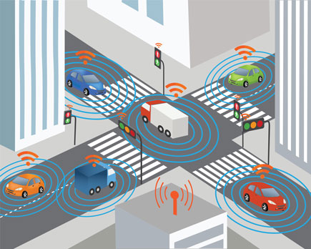 |  | 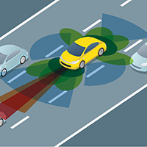
Connected vehicles are vehicles that use various communication technologies to exchange information with other cars, roadside infrastructure, and the Cloud. | vs. | Autonomous, or “self-driving” vehicles, are vehicles in which operation of the vehicle occurs with limited, if any, direct driver input.
Communication Types |  | Levels of Automation

Potential Timeline

Potential Transportation Impacts

Overall Safety – In the long-term, CAV technology is anticipated to reduce human error and improve overall traffic safety.
Bicycle and Pedestrian Safety – CAV interactions with bicyclists and pedestrians is a major area of concern that still needs improvement.
Traffic – CAVs have the potential to improve overall traffic flow and reduce congestion, even as they may increase vehicle miles traveled.
Big Data for Planning – Connected vehicle technology may provide valuable historical and real-time travel data for transportation planning.

P
Parking Reform – Autonomous vehicles could dramatically reduce demand for parking, opening this space up for other uses.
Transit – CAV technology has the potential to drastically reduce the cost of operating transit in environments that are safe for autonomous transit.
Freight – Both delivery and long-haul freight look to be early adopters of CAV technology, reducing costs and improving safety and congestion.
Development Patterns – The benefits of CAV technology may make longer commutes more attractive and increase urban sprawl.

Electric and Alternative Fuel Vehicles
There has been growing interest and investment in alternative fuel vehicle technologies in recent years, especially for electric vehicles. This renewed interest has also included the transit and freight industries. By 2030, some projections show electric vehicles making up nearly one-third of all cars in the United States.

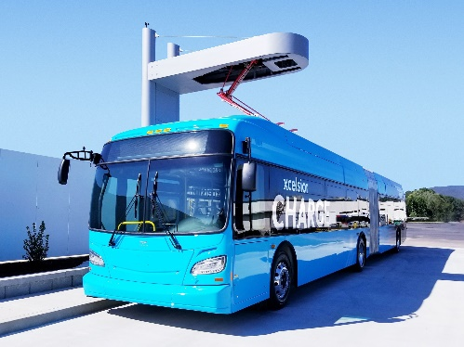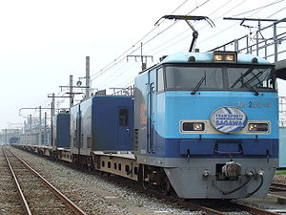

Potential Transportation Impacts

Air Quality Improvement – Electric and other alternative fuel vehicles have the potential to drastically reduce automobile related emissions.
Infrastructure Needs – There may be a long-term need for public investment in vehicle charging stations.
Gas Tax Revenues – If adoption rates increase substantially, gas tax revenues will be impacted and new user fees may need to be considered.

4.0 The Vision
The vision and goals in this plan lay the foundation for identifying strategies and projects that will help the region meet its established performance targets.

Strategic Framework and Vision
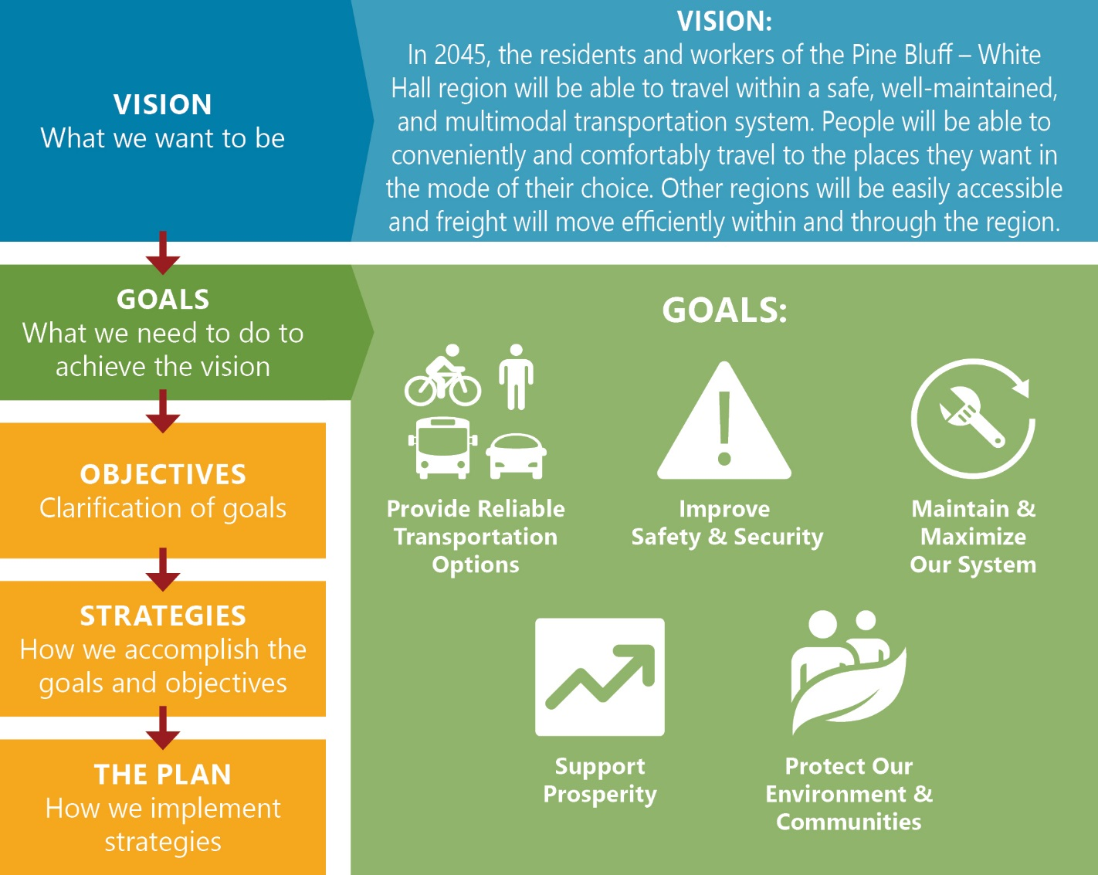
Reference: Appendix #5: Plan Development, Chapter 5, Page 28

Goals and Objectives
Goal: Provide Reliable Transportation Options
TO.1 Reduce roadway congestion and delay
TO.2 Make more areas in the region walkable and bikeable
TO.3 Expand and improve transit to meet the needs of the region
TO.4 Support convenient and affordable access to surrounding airports and regions
Goal: Improve Safety and Security
SS.1 Redesign corridors and areas with existing safety and security needs
SS.2 Coordinate with local and state stakeholders to improve enforcement of traffic regulations, transportation safety education, and emergency response
SS.3 Encourage the use of Intelligent Transportation Systems and other technology during disruptive incidents, including evacuation events
Goal: Maintain and Maximize Our System
MM.1 Maintain transportation infrastructure and assets in a good state of repair
MM.2 Reduce demand for roadway expansion by using technology to efficiently and dynamically manage roadway capacity

Goal: Support Prosperity
SP.1 Pursue transportation improvements that are consistent with local plans for growth and economic development
SP.2 Support local businesses and industry by ensuring efficient movement of freight by truck, rail, and other modes
SP.3 Address the unique needs of visitors to the region and the impacts of tourism
SP.4 Promote context-sensitive transportation solutions that integrate land use and transportation planning and reflect community values
Goal: Protect Our Environment and Communities
EC.1 Minimize or avoid adverse impacts from transportation improvements to the natural environment and the human environment (historic sites, recreational areas, environmental justice populations)
EC.2 Encourage proven Green Infrastructure and other design approaches that effectively manage and mitigate stormwater runoff
EC.3 Work with local and state stakeholders to meet the growing needs of electric and alternative fuel vehicles
EC.4 Increase the percentage of workers commuting by carpooling, transit, walking, and biking

Reference: Appendix #5, Chapter 5, Page 29

Performance Measures
Using a performance-based approach to transportation planning helps the region understand its current needs and allows planners and decision-makers to track progress over time. Federal legislation required the MPO to adopt performance targets for several federally required transportation performance measures. The MPO is also responsible for monitoring performance for these measures over time.

Current Performance
The graphic below summarizes how the MPO and region are performing today regarding these required performance measures. For more detailed information, see Appendix #3: Transportation Performance Management.
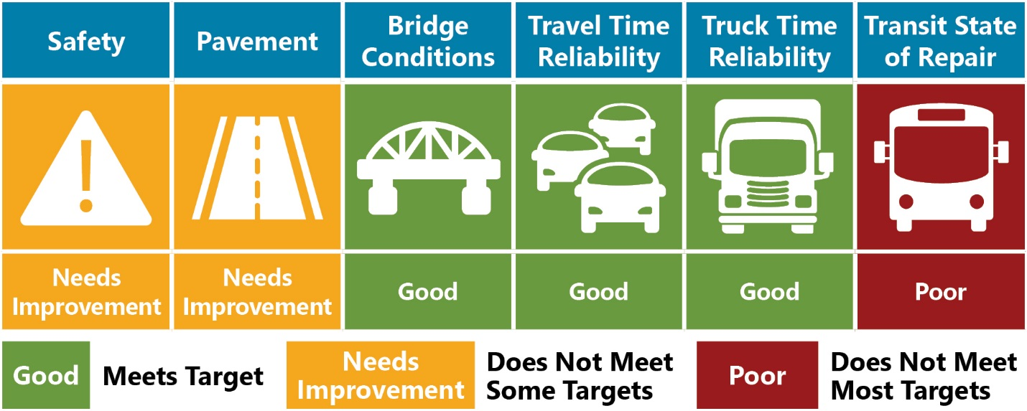
Reference: Appendix #3: Transportation Performance Measures

Improving Performance
The MTP uses data and stakeholder input to identify the root causes of poor performance in federally required performance measures. It prioritizes investments that will improve current and future performance.

5.0 Implementation
This section presents the strategies and associated improvement plan that will help the region achieve its goals and meet its performance targets. It also provides guidance on the next steps for the MPO.

Strategies
These strategies, identified from a technical needs assessment and stakeholder and public input, will help the region achieve the transportation goals previously stated.

Responsibly Improve Roadway System
Funding for new roads and widening roads is limited. The MPO will prioritize roadway expansion projects that have a high benefit/cost ratio.

Improve and Expand Public Transportation
Improve existing transit services in the City of Pine Bluff. Explore additional funding options and consider expanding transit services to the City of White Hall and beyond.

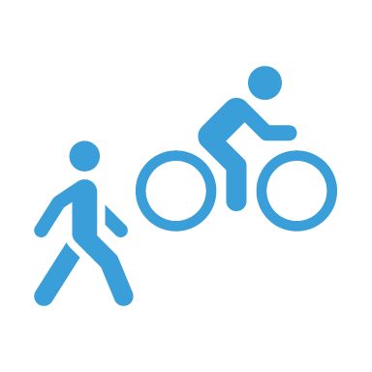
Rapidly Expand Biking and Walking Infrastructure
There were frequent comments from public input were for better walking and biking conditions. The MPO should encourage more bicycle and pedestrian projects and encourage bicycle and pedestrian improvements as part of planned roadway projects.

Prioritize Maintenance
The MPO should proactively address pavement conditions, bridge conditions, and transit asset management. Additional studies may be worthwhile to collect maintenance data on roadways outside of the National Highway System. Maintenance needs were the most often identified needs in the stakeholder consultation and public input.

Establish a Safety Management System
The typical traffic safety program includes a crash record system, identification of hazardous locations, engineering studies, selection of countermeasures, prioritization of projects, planning and implementation, and evaluation.

Monitor Emerging Technology Options
Transportation technology is changing rapidly but much is still uncertain. The MPO should continue to monitor trends in emerging mobility options and consider partnerships with mobility companies and pilot programs as appropriate.
CAV

Roadway Projects
Over the next 25 years, the MPO plans to implement a variety of roadway capacity projects (adding lanes or new roadways) and roadway non-capacity projects (overlays, signal retimings, etc.).

Fiscally Constrained Projects
The MPO receives funding from many federal sources and provides local funding in addition to federal funding. Based on projected funding, approximately $571 million in total funds will be available to the MPO for roadway projects from 2020 to 2045.

Reference: Appendix #5: Plan Development, Chapter 5, Pages 80-81 and Page 86

Prioritizing Roadway Capacity Projects
All roadway capacity projects identified in existing plans and the MTP needs analysis were prioritized based on the criteria below. High scoring projects were included in the fiscally constrained plan and the remaining projects are in a list of visionary projects.

Reference: Appendix #5: Plan Development, Chapter 8, Pages 72 and 73

Impact of Roadway Capacity Projects
Implementing the planned roadway capacity projects are projected to reduce overall delay in the region by one (1) percent in 2045. However, this is a function of the comparatively small amount of existing delay within the region and the low forecasted amount of growth over the next 25 years.
Reference: Appendix #5: Plan Development, Chapter 10, Page 87
2045 - No New Projects
Only Existing and Committed Projects
2045 - The Plan
All Existing, Committed, & Planned Projects
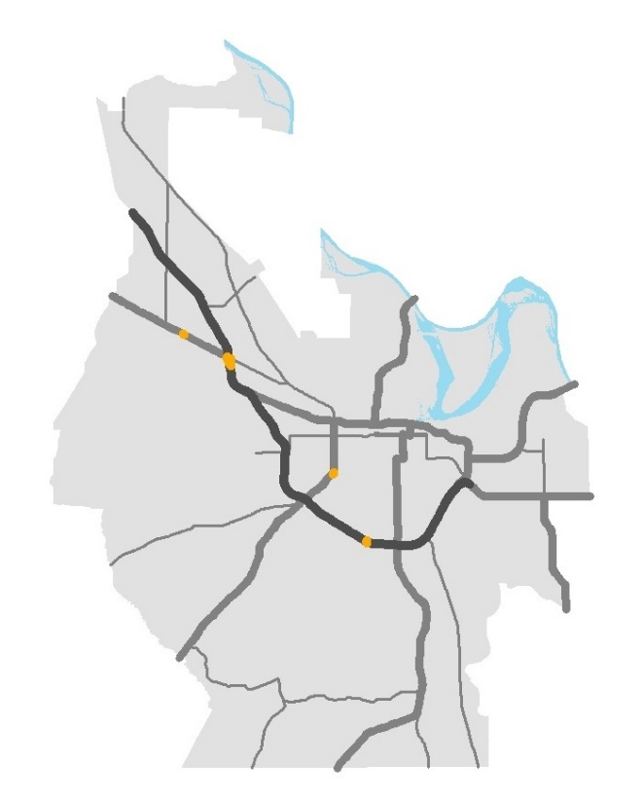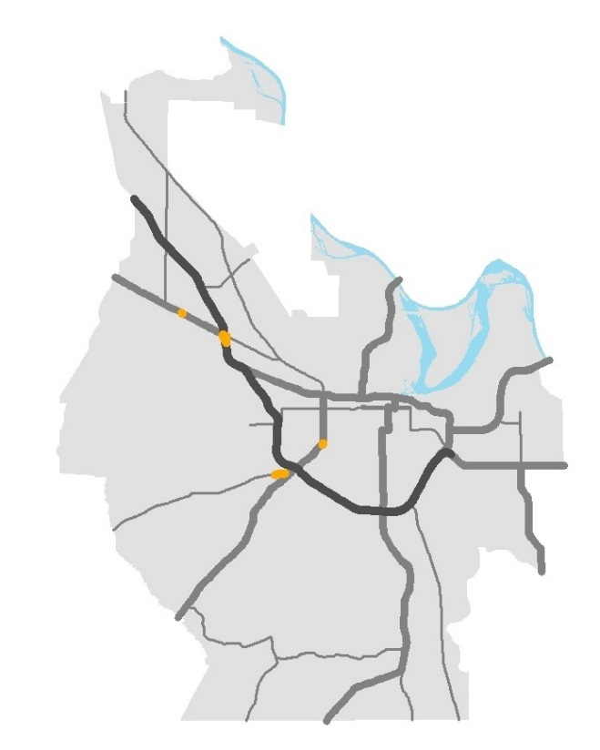
Reference: Pine Bluff Travel Demand Model
Fiscally Constrained Roadway Projects
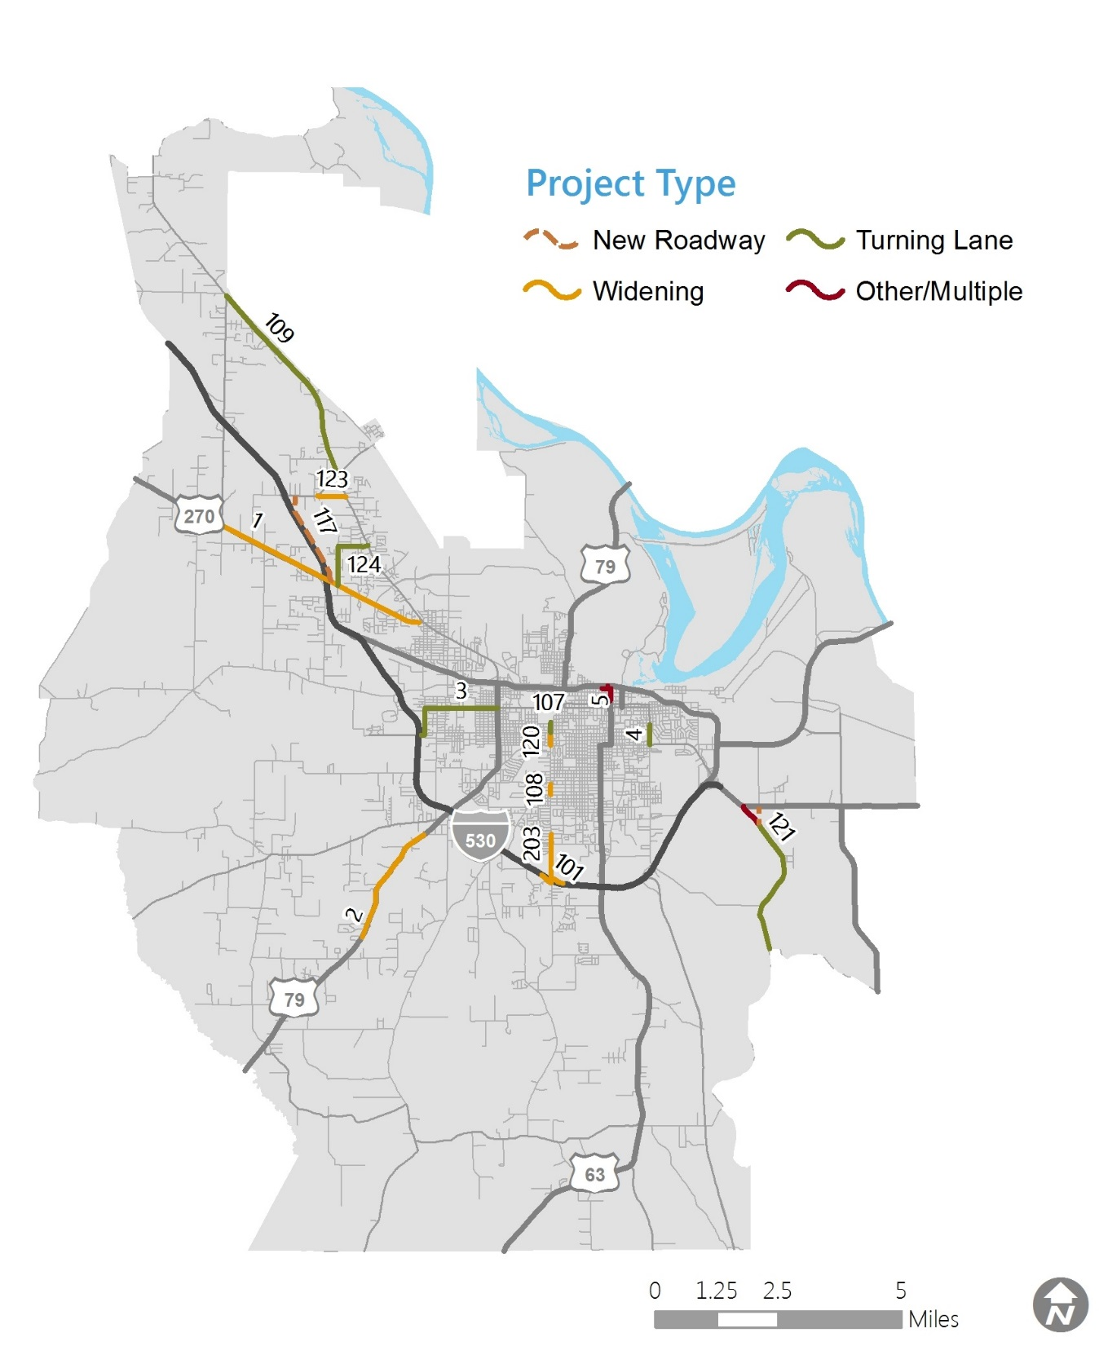
Reference: Appendix #5: Plan Development, Chapter 10, Pages 88 and 89

This page is intentionally left blank.

Fiscally Constrained Roadway Projects
MTP ID | Stage | Roadway | Limits | Length (Miles) | Type | Description | Year of Expenditure (YOE) | Total Cost (2020$) | Total Cost (YOE) | Design Considerations
1 | Stage 1 | US 270 & Hwy 365S (Sherridan Rd) | Hwy 104 to Hwy 365 | 4.59 |  | Widen to 5 Lanes | TIP | $15,000,000 | $15,000,000
2 | Stage 1 | US 79 (S Camden Rd) | Couch Ln to Suburbia Dr | 2.38 |  | Widen to 4 Lanes | TIP | $5,500,000 | $5,500,000
3 | Stage 1 | Hwy 190 (S Franklin St/W 6th Ave) | I-530 to Hwy 79B (S Blake St) | 2.09 |  | Center Turn Lane | TIP | $3,500,000 | $3,500,000
4 | Stage 1 | Hwy 190 (Ohio St) | 11th Ave to Harding Ave | 0.39 |  | Center Turn Lane | TIP | $1,700,000 | $1,700,000
5 | Stage 1 | Pine St; Barraque Ave; Main St | Martha Mitchel to Barraque; Walnut St to Main St; Barraque Ave to 4th Ave | 0.49 |  | Road Diet | TIP | COMPLETE | COMPLETE
LI-1 | Stage 1 NC | Line Item | Non-Capacity Projects and Flexible Funding | -- |  | Various | Stage 1 Total | $54,709,420 | $54,709,420
107 | Stage 2 | Hazel St Extension | W 13th Ave to Hwy 190 (W 6th Ave) | 0.50 |  | Center Turn Lane; New 3 Lane Roadway | 2026 | $2,883,200 | $3,246,951 | EJ
117 | Stage 2 | Caney Rd | Hwy 365 to Hwy 256 | 1.94 |  | New 2 Lane Roadway | 2027 | $5,946,100 | $6,830,200
124 | Stage 2 | Robin St/White Hall Rd | Hwy 65 B (Sherridan Rd) to Hwy 365 (Dollarway Rd) | 1.41 |  | Center Turn Lane | 2029 | $8,178,000 | $9,773,467 | EJ
203 | Stage 2 | Hazel St | I-530 to W 42nd Ave | 0.99 |  | Widen to 5 Lanes and New Bridge | Stage 2 Middle | $10,252,500 | $12,622,718 | EJ | EC
121 | Stage 2 | Grider Field - Ladd Rd | Hwy 980 to US 65 | 3.23 |  | Center Turn Lane; New 3 Lane Roadway | Stage 2 Middle | $18,734,000 | $23,065,008 | EJ | EC
LI-2 | Stage 2 NC | Line Item | Non-Capacity Projects and Flexible Funding | -- |  | Various | Stage 2 Total | $156,701,478 | $156,701,478
101 | Stage 3 | I-530 | Hazel St Exit Ramps | -- |  | Widen to 2 Lanes | Stage 3 Middle | $6,375,000 | $9,567,644 | EJ | EC
108 | Stage 3 | Hazel St | 31st Ave to 28th Ave | 0.22 |  | Widen to 5 Lanes | Stage 3 Middle | $1,485,000 | $2,228,698 | EJ
109 | Stage 3 | Hwy 365 (Dollarway Rd) | Hwy 104 to Hwy 256 | 4.43
120 | Stage 3 | Hazel St | 17th Ave to 13th Ave | 0.25
123 | Stage 3 | W Holland Ave | W Hoadley Rd to Hwy 356 | 0.60
LI-3 | Stage 3 NC | Line Item | Non-Capacity Projects and Flexible Funding | --
Note 1: YOE (Year of Expenditure) costs assume a 2% annual inflation rate.
Note 2: Bicycle and pedestrian improvements must be part of the overall design phase of all projects and included unless restrictions apply consistent with FHWA guidance.
Note 3: Stage 1 refers to the region’s short-term plan, 2020-2025.
Stage 2 refers to the region’s mid-term plan, 2025-2035.
Stage 3 refers to the region’s long-term plan, 2036-2045
Note 4: NC after a stage refers to non-capacity and flexible funding projects
Note 5: Stage 2 Middle and Stage 3 Middle refer to YOE costs at the middle of Stages 2 and 3, consistent with regulations and ArDOT procedure after the first 10 years of the MTP.
Improvement Type: New Roadway Widening Turning Lane Other/Multiple
Design Considerations: EJ – Potential Concern for Environmental Justice Impacts
EC – Potential Concern for Environmental and Community Impacts

MTP ID | Stage | Roadway | Limits | Length (Miles) | Type | Description | Year of Expenditure (YOE) | Total Cost (2020$) | Total Cost (YOE) | Design Considerations
1 | Stage 1 | US 270 & Hwy 365S (Sherridan Rd) | Hwy 104 to Hwy 365 | 4.59 |  | Widen to 5 Lanes | 2020 | $15,000,000 | $15,000,000
2 | Stage 1 | US 79 (S Camden Rd) | Couch Ln to Suburbia Dr | 2.38 |  | Widen to 4 Lanes | 2021 | $5,500,000 | $5,500,000
3 | Stage 1 | Hwy 190 (S Franklin St/W 6th Ave) | I-530 to Hwy 79B (S Blake St) | 2.09 |  | Center Turn Lane | 2021 | $3,500,000 | $3,500,000
4 | Stage 1 | Hwy 190 (Ohio St) | 11th Ave to Harding Ave | 0.39 |  | Center Turn Lane | 2021 | $1,700,000 | $1,700,000
5 | Stage 1 | Pine St; Barraque Ave; Main St | Martha Mitchel to Barraque; Walnut St to Main St; Barraque Ave to 4th Ave | 0.49 |  | Road Diet | COMPLETE | COMPLETE | COMPLETE
LI-1 | Stage 1 NC | Line Item | Non-Capacity Projects and Flexible Funding | -- |  | Various | Stage 1 Total | $54,709,420 | $54,709,420
107 | Stage 2 | Hazel St Extension | W 13th Ave to Hwy 190 (W 6th Ave) | 0.50 |  | Center Turn Lane; New 3 Lane Roadway | 2026 | $2,883,200 | $3,246,951 | EJ
117 | Stage 2 | Caney Rd | Hwy 365 to Hwy 256 | 1.94 |  | New 2 Lane Roadway | 2027 | $5,946,100 | $6,830,200
124 | Stage 2 | Robin St/White Hall Rd | Hwy 65 B (Sherridan Rd) to Hwy 365 (Dollarway Rd) | 1.41 |  | Center Turn Lane | 2029 | $8,178,000 | $9,773,467 | EJ
203 | Stage 2 | Hazel St | I-530 to W 42nd Ave | 0.99 |  | Widen to 5 Lanes and New Bridge | Stage 2 Middle | $10,252,500 | $12,622,718 | EJ | EC
121 | Stage 2 | Grider Field - Ladd Rd | Hwy 980 to US 65 | 3.23 |  | Center Turn Lane; New 3 Lane Roadway | Stage 2 Middle | $18,734,000 | $23,065,008 | EJ | EC
LI-2 | Stage 2 NC | Line Item | Non-Capacity Projects and Flexible Funding | -- |  | Various | Stage 2 Total | $156,701,478 | $156,701,478
101 | Stage 3 | I-530 | Hazel St Exit Ramps | -- |  | Widen to 2 Lanes | Stage 3 Middle | $6,375,000 | $9,567,644 | EJ | EC
108 | Stage 3 | Hazel St | 31st Ave to 28th Ave | 0.22 |  | Widen to 5 Lanes | Stage 3 Middle | $1,485,000 | $2,228,698 | EJ
 |  |  |  |  |  | Center Turn Lane | Stage 3 Middle | $25,694,000 | $38,561,732 | EC
 |  |  |  |  |  | Widen to 5 Lanes | Stage 3 Middle | $1,687,500 | $2,532,612 | EJ | EC
 |  |  |  |  |  | Widen to 4 Lanes | Stage 3 Middle | $4,050,000 | $6,078,268
 |  |  |  |  |  | Various | Stage 3 Total | $191,018,227 | $191,018,227

Visionary “Unfunded” Roadway Capacity Projects
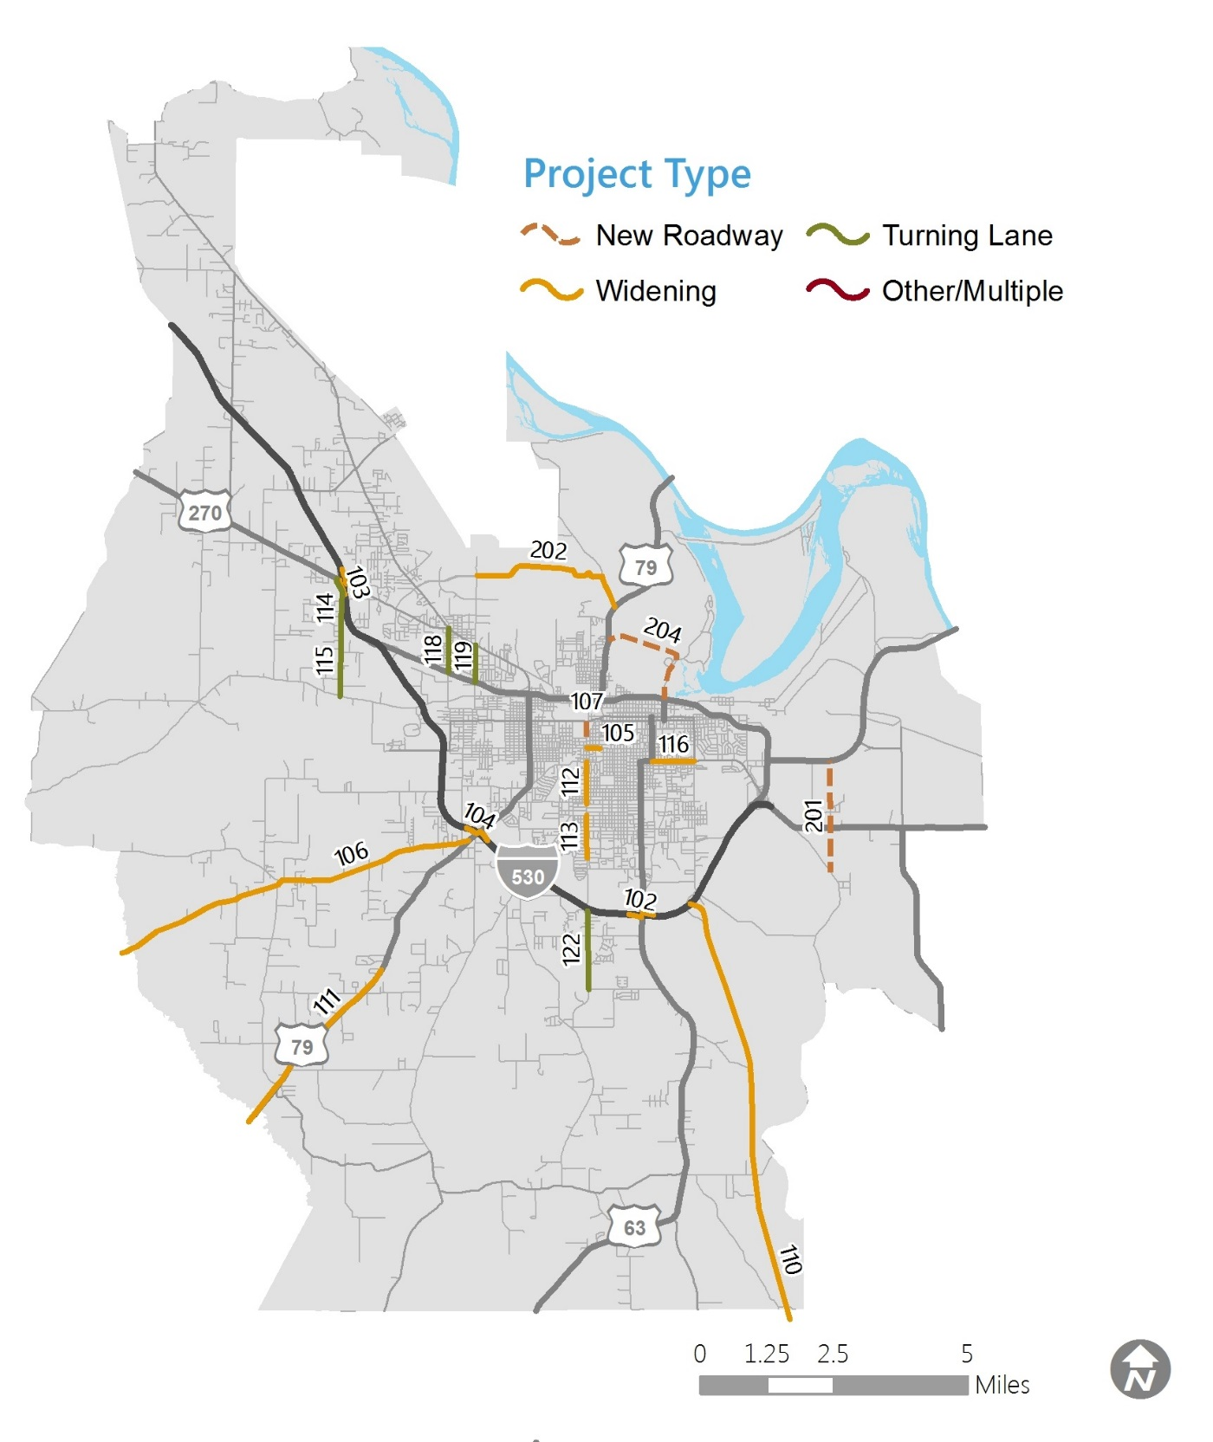
Reference: Appendix #5: Plan Development, Chapter 10, Page 93

This page is intentionally left blank.
Visionary Roadway Capacity Projects
MTP ID | Stage | Roadway | Limits | Length (Miles) | Type | Description | Total Cost (2020$) | Design Considerations
112 | Vision | Hazel St | 28th Ave to 17th Ave | 0.79 |  | Widen to 5 Lanes | $5,332,500 | EJ
118 | Vision | Bryant St | US 65B (Martha Mitchell Expwy) to  Hwy 365 (Dollarway Rd) | 0.83 |  | Center Turn Lane | $4,814,000 | EJ | EC
119 | Vision | Hutchinson St | US 65B (Martha Mitchell Expwy) to  Hwy 365 (Dollarway Rd) | 0.69 |  | Center Turn Lane | $4,002,000 | EJ
102 | Vision | I-530 | US 63 (S Olive St) Exit Ramps | -- |  | Widen to 2 Lanes | $6,375,000 | EJ | EC
103 | Vision | I-530 | US 270 Exit Ramps | -- |  | Widen to 2 Lanes | $6,375,000
104 | Vision | I-530 | US 79 (S Camden Rd) Exit Ramps | -- |  | Widen to 2 Lanes | $6,375,000 | EJ
105 | Vision | W 13th Ave | Hazel St to Hickory St | 0.25 |  | Widen to 4 Lanes | $1,687,500 | EJ
110 | Vision | Hwy 530 | Study Area Boundary to I-530 | 8.14 |  | Widen to 4 Lanes | $54,945,000 | EJ | EC
106 | Vision | Hwy 54 (Sulphur Springs Rd) | Study Area Boundary to US 79 | 6.95 |  | Widen to 4 Lanes | $46,912,500 | EC
113 | Vision | Hazel St | 42nd Ave to 31st Ave | 0.79 |  | Widen to 5 Lanes | $5,332,500 | EJ
116 | Vision | Harding Ave | Main St to Ohio St | 0.79 |  | Widen to 5 Lanes | $5,332,500 | EJ | EC
111 | Vision | US 79 (S Camden Rd) | Study Area Boundary to Suburbia Dr | 3.79 |  | Widen to 4 Lanes | $25,582,500 | EC
114 | Vision | Claude Rd | White Hall City Limits to US 270 | 0.96 |  | Center Turn Lane | $5,568,000 | EC
115 | Vision | Claude Rd | Princeton Pike to White Hall City Limits | 1.27 |  | Center Turn Lane | $7,366,000 | EC
122 | Vision | Hazel St | W 73rd Ave to I-530 | 1.47 |  | Center Turn Lane | $8,526,000 | EJ
201 | Vision | North-South Connector | Grider Field Ladd Rd to US 63 | 2.11 |  | New 2 Lane Roadway | $6,467,150 | EJ | EC
202 | Vision | Jefferson Hwy/McFadden Rd | N Hutchinson St to US 79 | 3.15 |  | Widen to 4 Lanes | $21,262,500 | EJ | EC
204 | Vision | University/Lake Saracen Bypass | US 65 B (Martha Mitchell Expwy) to  US 79 B (University Dr) | 2.21
Note: Bicycle and pedestrian improvements must be part of the overall design phase of all projects and included unless restrictions apply consistent with FHWA guidance.
Note 2: Vision projects are unfunded needs and as such do not have a Year of Expenditure associated with them. Costs are shown in 2020 dollars.
Design Considerations: EJ – Potential Concern for Environmental Justice Impacts
EC – Potential Concern for Environmental and Community Impacts
Improvement Type: New Roadway Widening Turning Lane

MTP ID | Stage | Roadway | Limits | Length (Miles) | Type | Description | Total Cost (2020$) | Design Considerations
112 | Vision | Hazel St | 28th Ave to 17th Ave | 0.79 |  | Widen to 5 Lanes | $5,332,500 | EJ
118 | Vision | Bryant St | US 65B (Martha Mitch Expwy) to  Hwy 365 (Dollarway Rd) | 0.83 |  | Center Turn Lane | $4,814,000 | EJ | EC
119 | Vision | Hutchinson St | US 65B (Martha Mitch Expwy) to  Hwy 365 (Dollarway Rd) | 0.69 |  | Center Turn Lane | $4,002,000 | EJ
102 | Vision | I-530 | US 63 (S Olive St) Exit Ramps | -- |  | Widen to 2 Lanes | $6,375,000 | EJ | EC
103 | Vision | I-530 | US 270 Exit Ramps | -- |  | Widen to 2 Lanes | $6,375,000
104 | Vision | I-530 | US 79 (S Camden Rd) Exit Ramps | -- |  | Widen to 2 Lanes | $6,375,000 | EJ
105 | Vision | W 13th Ave | Hazel St to Hickory St | 0.25 |  | Widen to 4 Lanes | $1,687,500 | EJ
110 | Vision | Hwy 530 | Study Area Boundary to I-530 | 8.14 |  | Widen to 4 Lanes | $54,945,000 | EJ | EC
106 | Vision | Hwy 54 (Sulphur Springs Rd) | Study Area Boundary to US 79 | 6.95 |  | Widen to 4 Lanes | $46,912,500 | EC
113 | Vision | Hazel St | 42nd Ave to 31st Ave | 0.79 |  | Widen to 5 Lanes | $5,332,500 | EJ
116 | Vision | Harding Ave | Main St to Ohio St | 0.79 |  | Widen to 5 Lanes | $5,332,500 | EJ | EC
111 | Vision | US 79 (S Camden Rd) | Study Area Boundary to Suburbia Dr | 3.79 |  | Widen to 4 Lanes | $25,582,500 | EC
114 | Vision | Claude Rd | White Hall City Limits to US 270 | 0.96 |  | Center Turn Lane | $5,568,000 | EC
115 | Vision | Claude Rd | Princeton Pike to White Hall City Limits | 1.27 |  | Center Turn Lane | $7,366,000 | EC
122 | Vision | Hazel St | W 73rd Ave to I-530 | 1.47 |  | Center Turn Lane | $8,526,000 | EJ
201 | Vision | North-South Connector | Grider Field Ladd Rd to US 63 | 2.11 |  | New 2 Lane Roadway | $6,467,150 | EJ | EC
202 | Vision | Jefferson Hwy/McFadden Rd | N Hutchinson St to US 79 | 3.15 |  | Widen to 4 Lanes | $21,262,500 | EJ | EC
204 | Vision | University/Lake Saracen Bypass | US 65 B (Martha Mitchell Expwy) to  US 79 B (University Dr) | 2.21 |  | New 2 Lane Roadway | $13,913,650 | EJ | EC

Bicycle and Pedestrian Projects
In addition to bicycle and pedestrian improvements included with planned roadway projects, the region will continue to fund stand-alone bicycle and pedestrian projects

Financial Plan
The major federal source for bicycle and pedestrian projects is the Transportation Alternatives (TA) Set-Aside program, administered by ArDOT. Based on historical funding levels and the region’s share of the state population, this plan assumes that approximately $5.6 million in federal TA funds will be available to the MPO from 2020 to 2045. The MPO currently only has five (5) TA-funded projects, one of which has been completed and not shown below, and local governments should continue to apply for these projects.
Reference: Appendix #5: Plan Development, Chapter 10, Pages 82-83 and Page 87

This page is intentionally left blank.

Fiscally Constrained Bicycle and Pedestrian Projects
MTP ID | Stage | Roadway | Limits | Length (Miles) | Type | Description | Year of Expenditure (YOE) | Total Cost (2020$) | Total Cost (YOE) | Design Considerations
BP-1 | Stage 1 NC | Hwy 270 & Hwy 365S | Hwy 104 to Hwy 365S | 4.59 |  | Add Sidewalks | TIP | $15,000,000 | $15,000,000
BP-2 | Stage 1 NC | US 79 | Couch Ln to Suburbia | 2.38 |  | Add Sidewalks | TIP | $5,500,000 | $5,500,000
BP-3 | Stage 1 NC | US 190 | I-530 to Hwy 79B | 2.09 |  | Add Sidewalks | TIP | $3,500,000 | $3,500,000
BP-4 | Stage 1 NC | US 190 | 11th Ave to Harding Ave | 0.39 |  | Add Sidewalks | TIP | $1,700,000 | $1,700,000
Note 1: YOE (Year of Expenditure) costs assume a 2% annual inflation rate.
Note 2: Bicycle and pedestrian improvements must be part of the overall design phase of all projects and included unless restrictions apply consistent with FHWA guidance.
Note 3: Stage 1 refers to the region’s short-term plan, 2020-2025.
Note 4: NC after a stage refers to non-capacity and flexible funding projects
Improvement Type: Other/Multiple
Design Considerations: EJ – Potential Concern for Environmental Justice Impacts
EC – Potential Concern for Environmental and Community Impacts

MTP ID | Stage | Roadway | Limits | Length (Miles) | Type | Description | Year of Expenditure (YOE) | Total Cost (2020$) | Total Cost (YOE) | Design Considerations
BP-1 | Stage 1 NC | Hwy 270 & Hwy 365S | Hwy 104 to Hwy 365S | 4.59 |  | Add Sidewalks | TIP | $15,000,000 | $15,000,000
BP-2 | Stage 1 NC | US 79 | Couch Ln to Suburbia | 2.38 |  | Add Sidewalks | TIP | $5,500,000 | $5,500,000
BP-3 | Stage 1 NC | US 190 | I-530 to Hwy 79B | 2.09 |  | Add Sidewalks | TIP | $3,500,000 | $3,500,000
BP-4 | Stage 1 NC | US 190 | 11th Ave to Harding Ave | 0.39 |  | Add Sidewalks | TIP | $1,700,000 | $1,700,000

Public Transit Projects
Over the next 25 years, the region will continue to provide the fixed route and complementary paratransit service operated by Pine Bluff Transit.

Financial Plan
If recent funding levels continue, the region will have enough federal funding to continue operating its transit service at current levels. The main limitation to expanding service will be local funding to match and exceed federal funding, as needed. Pine Bluff Transit has also received a one-time CARES Act grant for $2.2 million, which can be used for planning, operating, and capital costs.

Reference: Appendix #5: Plan Development, Chapter 10, Pages 84-85 and Page 87

Transit Optimization and Expansion Study
The demand analysis and public input showed a demand for increased transit in the region, particularly for fixed route service in the City of White Hall and in the Pine Bluff neighborhood of Watson Chapel. Outside of these areas, there is need for less frequent transit that connects the rural areas of the MPA to critical services. Within the City of Pine Bluff, the current fixed routes could be more frequent and reliable. Additionally, providing up-to-date transit information for riders and increasing marketing can help connect interested riders to transit services. A general Transit Optimization and Expansion Study should be conducted that addresses the following questions:
- How can current transit service be improved?
- What new services should be provided and where?
- What funds are available and what new funding sources are viable options?
- What are the steps for implementation?

This page is intentionally left blank.
Public Transit Projects
MTP ID | TIP ID | Description | Type | Fiscal Year | Total Cost (YOE)¹ | Federal Cost (YOE)¹
PT-1 | PBT001 | SECTION 5307 PBT TRANSIT OPERATING ASSISTANCE |  | 2020 | $766,000 | $383,000
PT-2 | PBT002 | SECTION 5307 PBT CAPITAL- PREVENTIVE MAINTENANCE |  | 2020 | $258,000 | $206,000
PT-3 | PBT003 | SECTION 5307 PBT CAPITAL- PARATRANSIT SERVICE |  | 2020 | $153,000 | $122,000
PT-4 | PBT004 | SECTION 5307 PBT CAPITAL- ROLLING STOCK/SUPPORT EQUIPMENT |  | 2020 | $51,000 | $41,000
PT-5 | PBT005 | SECTION 5307 CAPITAL- PLANNING |  | 2020 | $25,000 | $20,000
PT-6 | PBT001 | SECTION 5307 PBT TRANSIT OPERATING ASSISTANCE |  | 2021 | $780,000 | $390,000
PT-7 | PBT002 | SECTION 5307 PBT CAPITAL- PREVENTIVE MAINTENANCE |  | 2021 | $263,000 | $210,000
PT-8 | PBT003 | SECTION 5307 PBT CAPITAL- PARATRANSIT SERVICE |  | 2021 | $156,000 | $125,000
PT-9 | PBT004 | SECTION 5307 PBT CAPITAL- ROLLING STOCK/SUPPORT EQUIPMENT |  | 2021 | $53,000 | $42,000
PT-10 | PBT005 | SECTION 5307 CAPITAL- PLANNING |  | 2021 | $26,000 | $21,000
PT-21 | n/a | TRANSIT EXPANSION FEASIBILITY STUDY
PT-11 | PBT001 | SECTION 5307 PBT TRANSIT OPERATING ASSISTANCE |  | 2022 | $796,000 | $398,000
PT-12 | PBT002 | SECTION 5307 PBT CAPITAL- PREVENTIVE MAINTENANCE |  | 2022 | $268,000 | $214,000
PT-13 | PBT003 | SECTION 5307 PBT CAPITAL- PARATRANSIT SERVICE |  | 2022 | $159,000 | $127,000
PT-14 | PBT004 | SECTION 5307 PBT CAPITAL- ROLLING STOCK/SUPPORT EQUIPMENT |  | 2022 | $53,000 | $42,000
PT-15 | PBT005 | SECTION 5307 CAPITAL- PLANNING |  | 2022 | $26,000 | $21,000
PT-16 | n/a | SECTION 5307 PBT TRANSIT OPERATING ASSISTANCE |  | 2023-2045 | $23,448,000 | $11,724,000
PT-17 | n/a | SECTION 5307 PBT CAPITAL- PREVENTIVE MAINTENANCE |  | 2023-2045 | $7,898,000 | $6,306,000
PT-18 | n/a | SECTION 5307 PBT CAPITAL- PARATRANSIT SERVICE |  | 2023-2045 | $4,683,000 | $3,734,000
PT-19 | n/a | SECTION 5307 PBT CAPITAL- ROLLING STOCK/SUPPORT EQUIPMENT |  | 2023-2045 | $1,561,000 | $1,255,000
PT-20 | n/a | SECTION 5307 CAPITAL- PLANNING |  | 2023-2045 | $765,000 | $612,000
¹ YOE (Year of Expenditure) costs assume a 2% annual inflation rate for transit projects.
² The 2020 CARES Act funds may be used for this cost. $2,190,687 is apportioned for the Pine Bluff UZA.
Improvement Type: Operating Capital Study

MTP ID | TIP ID | Description | Type | Fiscal Year | Total Cost (YOE)¹ | Federal Cost (YOE)¹
PT-1 | PBT001 | SECTION 5307 PBT TRANSIT OPERATING ASSISTANCE |  | 2020 | $766,000 | $383,000
PT-2 | PBT002 | SECTION 5307 PBT CAPITAL- PREVENTIVE MAINTENANCE |  | 2020 | $258,000 | $206,000
PT-3 | PBT003 | SECTION 5307 PBT CAPITAL- PARATRANSIT SERVICE |  | 2020 | $153,000 | $122,000
PT-4 | PBT004 | SECTION 5307 PBT CAPITAL- ROLLING STOCK/SUPPORT EQUIPMENT |  | 2020 | $51,000 | $41,000
PT-5 | PBT005 | SECTION 5307 CAPITAL- PLANNING |  | 2020 | $25,000 | $20,000
PT-6 | PBT001 | SECTION 5307 PBT TRANSIT OPERATING ASSISTANCE |  | 2021 | $780,000 | $390,000
PT-7 | PBT002 | SECTION 5307 PBT CAPITAL- PREVENTIVE MAINTENANCE |  | 2021 | $263,000 | $210,000
PT-8 | PBT003 | SECTION 5307 PBT CAPITAL- PARATRANSIT SERVICE |  | 2021 | $156,000 | $125,000
PT-9 | PBT004 | SECTION 5307 PBT CAPITAL- ROLLING STOCK/SUPPORT EQUIPMENT |  | 2021 | $53,000 | $42,000
PT-10 | PBT005 | SECTION 5307 CAPITAL- PLANNING |  | 2021 | $26,000 | $21,000
PT-21 | n/a | TRANSIT EXPANSION FEASIBILITY STUDY |  | 2021 | $125,000 | $0²
PT-11 | PBT001 | SECTION 5307 PBT TRANSIT OPERATING ASSISTANCE |  | 2022 | $796,000 | $398,000
PT-12 | PBT002 | SECTION 5307 PBT CAPITAL- PREVENTIVE MAINTENANCE |  | 2022 | $268,000 | $214,000
PT-13 | PBT003 | SECTION 5307 PBT CAPITAL- PARATRANSIT SERVICE |  | 2022 | $159,000 | $127,000
PT-14 | PBT004 | SECTION 5307 PBT CAPITAL- ROLLING STOCK/SUPPORT EQUIPMENT |  | 2022 | $53,000 | $42,000
PT-15 | PBT005 | SECTION 5307 CAPITAL- PLANNING |  | 2022 | $26,000 | $21,000
PT-16 | n/a | SECTION 5307 PBT TRANSIT OPERATING ASSISTANCE |  | 2023-2045 | $23,448,000 | $11,724,000
PT-17 | n/a | SECTION 5307 PBT CAPITAL- PREVENTIVE MAINTENANCE |  | 2023-2045 | $7,898,000 | $6,306,000
PT-18 | n/a | SECTION 5307 PBT CAPITAL- PARATRANSIT SERVICE |  | 2023-2045 | $4,683,000 | $3,734,000
PT-19 | n/a | SECTION 5307 PBT CAPITAL- ROLLING STOCK/SUPPORT EQUIPMENT |  | 2023-2045 | $1,561,000 | $1,255,000
PT-20 | n/a | SECTION 5307 CAPITAL- PLANNING |  | 2023-2045 | $765,000 | $612,000

Next Steps

Implementation Timeline
In the next 5 years...
Update the Plan
- Adjust Metropolitan Planning Area following 2020 Census.
- Update MTP, incorporating new projects from studies and re-assessing emerging mobility options.
Right now...
Coordinate
- Continue coordinating with ArDOT to advance projects in the TIP and MTP.
- Dedicate upcoming planning funding for corridor and intersection studies.
- Dedicate upcoming planning funding for a transit study.
In the next 2 years...
Advance Projects
- Conduct corridor and intersection studies.
- Conduct a transit study.
- Apply for TA funding for high-priority bike/ped projects.
- Update Performance Targets and Report.
Short-Term
Ongoing
Long-Term

This page is intentionally left blank.

